1. **Control algorithm for dosing iron salts in sewers**

* 1. **Background**

One of the most widely used method for H2S mitigation is the addition of iron salts including ferrous chloride, ferric chloride and in some cases ferrous sulfate. Ferrous ions (Fe2+) precipitate sulfide by forming highly insoluble metallic sulfide precipitates. Ferric ions (Fe3+) oxidize sulfide to elemental sulfur while being reduced into Fe2+, which precipitates with sulfide to form ferrous sulfide precipitants.

$2{Fe}^{3+}+S^{2-}\overset{→}{}2{Fe}^{2+}+S^{0}$ (19)

${Fe}^{2+}+{HS}^{-}\overset{→}{}FeS+H^{+}$ (20)

The Fe:S molar ratio to be dosed is strongly dependent on wastewater pH. Given the large pH dynamics in sewer systems, sewage pH is a key parameter for the control algorithm.

|  |
| --- |
| Further information can be obtained as follows:   * Effects of iron salts dosing:   + **Paper:** Firer, D., Friedler, E. and Lahav, O. (2008) Control of sulfide in sewer systems by dosage of iron salts: Comparison between theoretical and experimental results, and practical implications. Science of the Total Environment 392(1), 145-156.   + **Paper:** Zhang, L., Keller, J. and Yuan, Z. (2009) Inhibition of sulfate-reducing and methanogenic activities of anaerobic sewer biofilms by ferric iron dosing. Water Research 43(17), 4123-4132. |

* 1. **Control Strategy**
     1. **Dosing Location**

The dosing location of iron salts is not important in terms of effectiveness of the chemical, as long as the hydraulic retention time (HRT) in the pipe after dosing allows sufficient time for sulfide precipitation (in the order of seconds).

According to recent findings that Fe3+ significantly inhibits SRB activity of anaerobic sewer biofilms, iron salts should preferably be added at upstream locations. Benefit of dosing upstream is that sulfide would be controlled along the entire pipe. However, this necessitates complex dosing control, potentially requiring pH and sulfide prediction for the downstream.

* + 1. **Dosing rate**

Given the theoretical pH dependence of FeS precipitation, the dosing rate needs to be calculated based on total dissolved sulfide (TDS) and pH levels at discharge point. When conducting the dosing at the beginning of the pressure main, both parameters need to be estimated.

Sulfide production will largely depend on hydraulic retention time of the sewage in the pipe. Sewage pH at downstream will be governed by pH at the dosing point and the bio-transformations taking place during its transportation along the pipe, which also depend on HRT.

* + - 1. *HRT prediction*

Typical hydraulic retention time (HRT) profiles have been used for the online control. This solution is not ideal because of the high variance in sewers. To achieve a better HRT estimation, sewer future flow prediction is obtained through a multi-step auto-regressive moving average (ARMA) models. The prediction during rain or storm events can be enhanced with exogenous inputs (ARMAX) model.

The ARMA model is composed of both autoregressive (AR) and moving average (MA) models. Equation 2 depicts a general expression to represent an ARMA model:

$A(z^{-1})y\left(t\right)=C\left(z^{-1}\right)v(t)$ (2)

Where $z$ is the backshift operator, $z^{-1}y\left(t\right)=y\left(t-1\right), v\left(t\right)$ is zero mean value Gaussian white noise and $y\left(t\right)$ is the observed data.

$A\left(z\right)=1+a_{1}z^{-1}+⋯+a_{na}z^{-na}$ (3)

$C\left(z\right)=1+c_{1}z^{-1}+⋯+c_{nc}z^{-nc}$ (4)

Where *na*, *nc* are the order of $A(z^{-1})$, $C\left(z^{-1}\right)$.

ARMA model allowed predicting future flow with reasonably good accuracy under different weather conditions (Figure 2). The delay on the prediction under changing conditions, which is accented at longer prediction times.

|  |
| --- |
| Further information can be obtained as follows:   * ARMA model for sewer flow prediction:   + **Paper:** Real-time Multistep Prediction of Sewer Flow for Online Chemical Dosing Control |

* + - 1. *Sewage pH prediction*

Sewage pH at the discharge depends on several factors including pH at the influent, retention time and buffer capacity of the wastewater. Previous field studies demonstrated that buffer capacity is almost constant along the day. The impact of influent pH and HRT on the sewage pH at discharge is assessed in Figure 1.

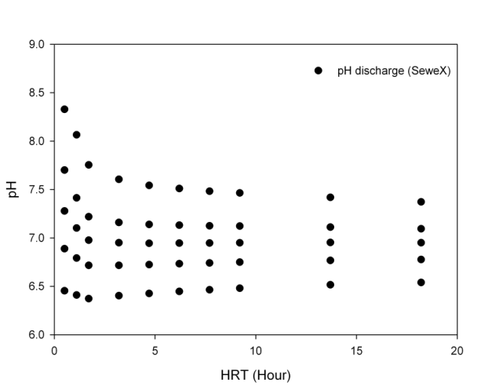

Figure 1. pH at discharge as a function of influent pH and HRT.

* + 1. **Control scheme**

The control algorithm for the optimised dosing of iron salts is composed of a feedforward and a feedback loop. The feedforward loop will predict pH and TDS downstream based on flow measurements and pH at the wet well, and based on that calculate the theoretical iron dosing requirements. In addition, the feedback loop can adjust the dosing based on the overall performance. The feedback loop will also assess the pH prediction and re-adjust the pH prediction model if necessary. A scheme of the control algorithm is depicted in Figure 2.

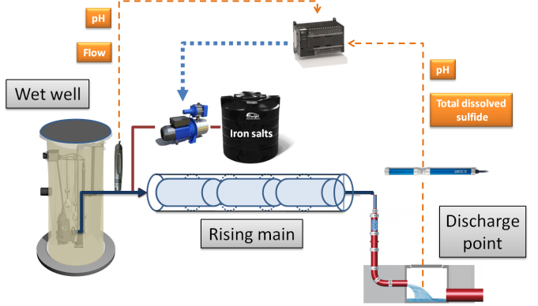

Figure 2. Control algorithm scheme for iron dosing.

* 1. **Case studies**

Ferrous dosing in the Bellambi sewer system (Sydney water) in Wollongong, Australia